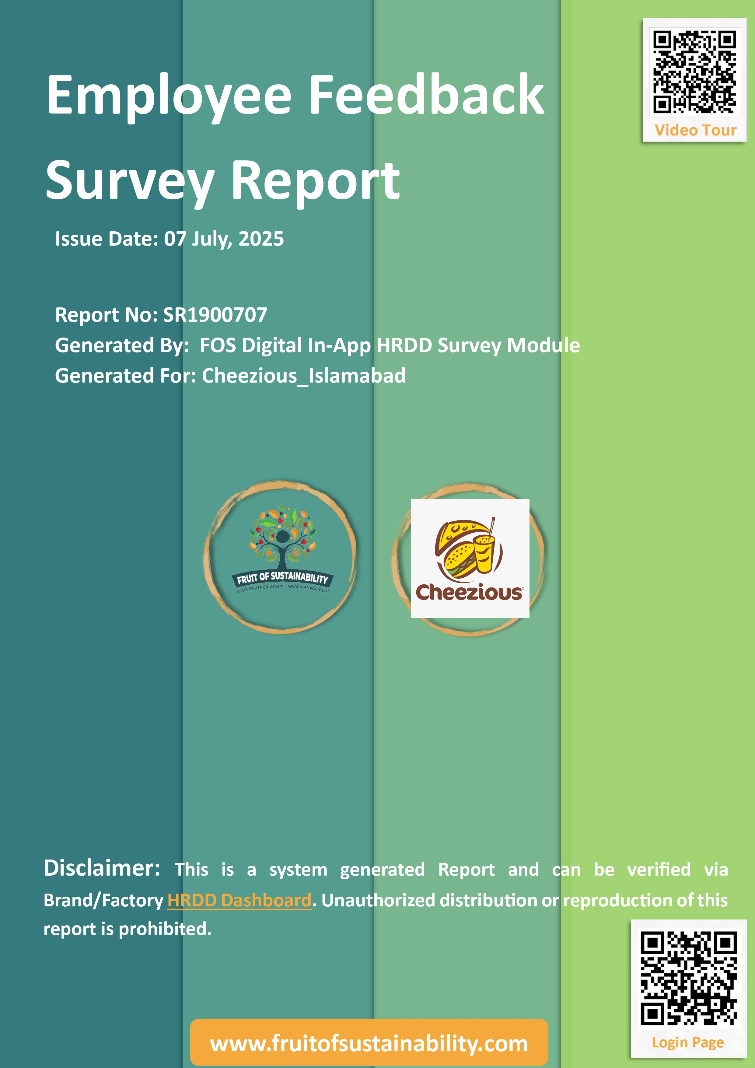

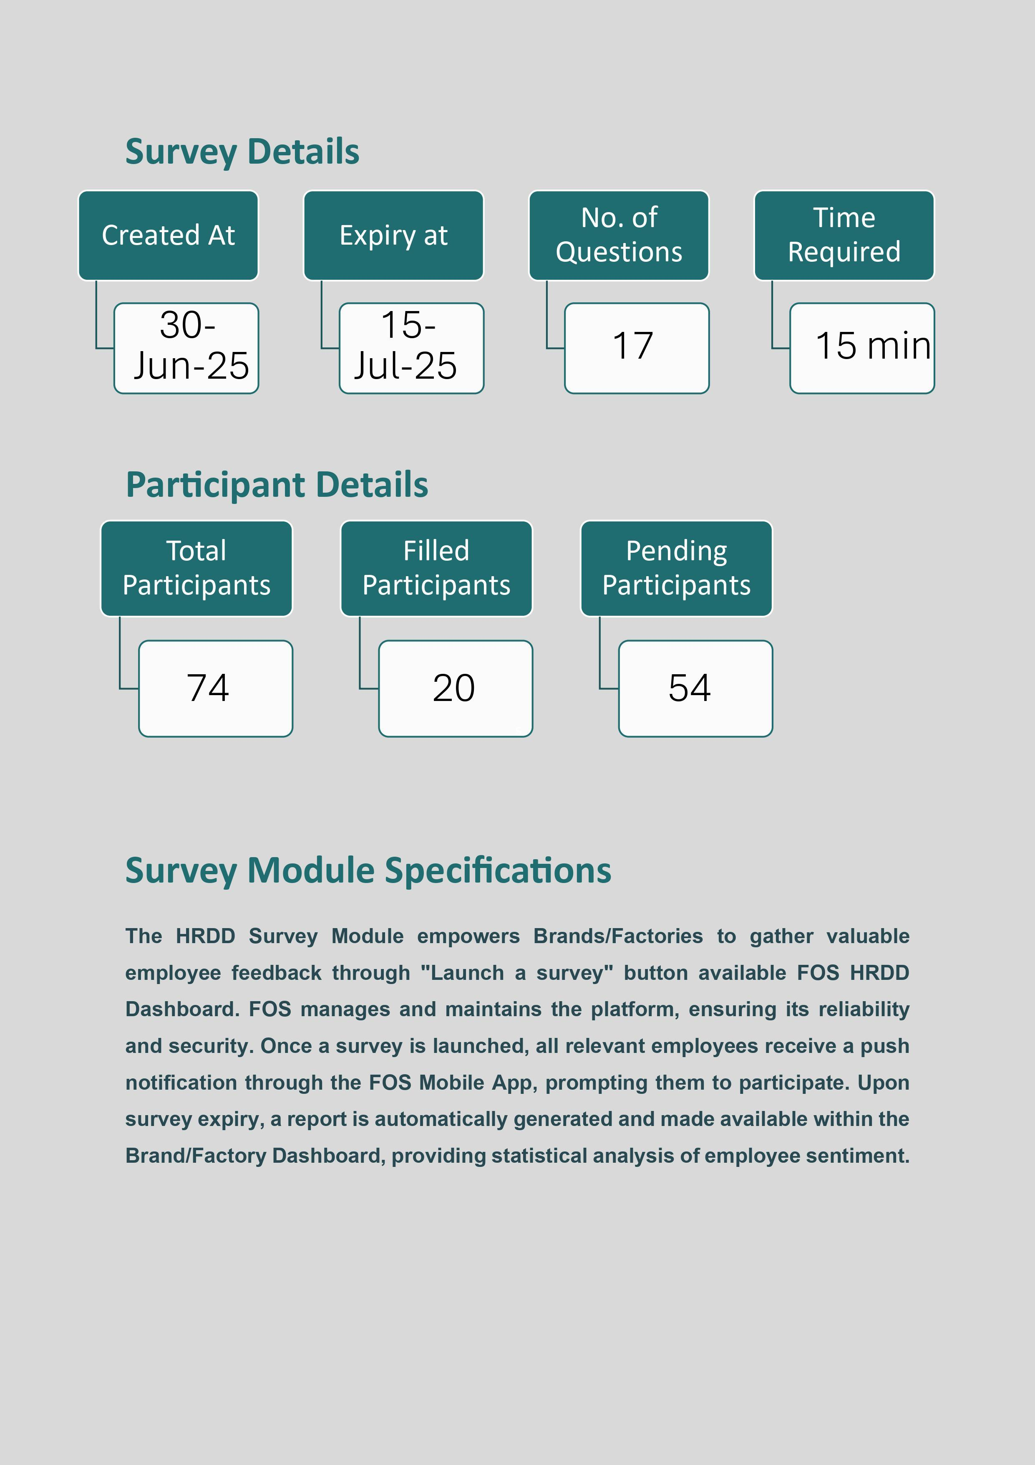

**Survey Results**

|  |  |
| --- | --- |
| Title | Description |
| Employee Well Being Survey (CHZ Call Centre) | This anonymous survey is to receive your honest feedback about your experiences at workplace. Your privacy is fully protected. |

**Q1. Do you know that your name will not be mentioned or recorded in this survey?**

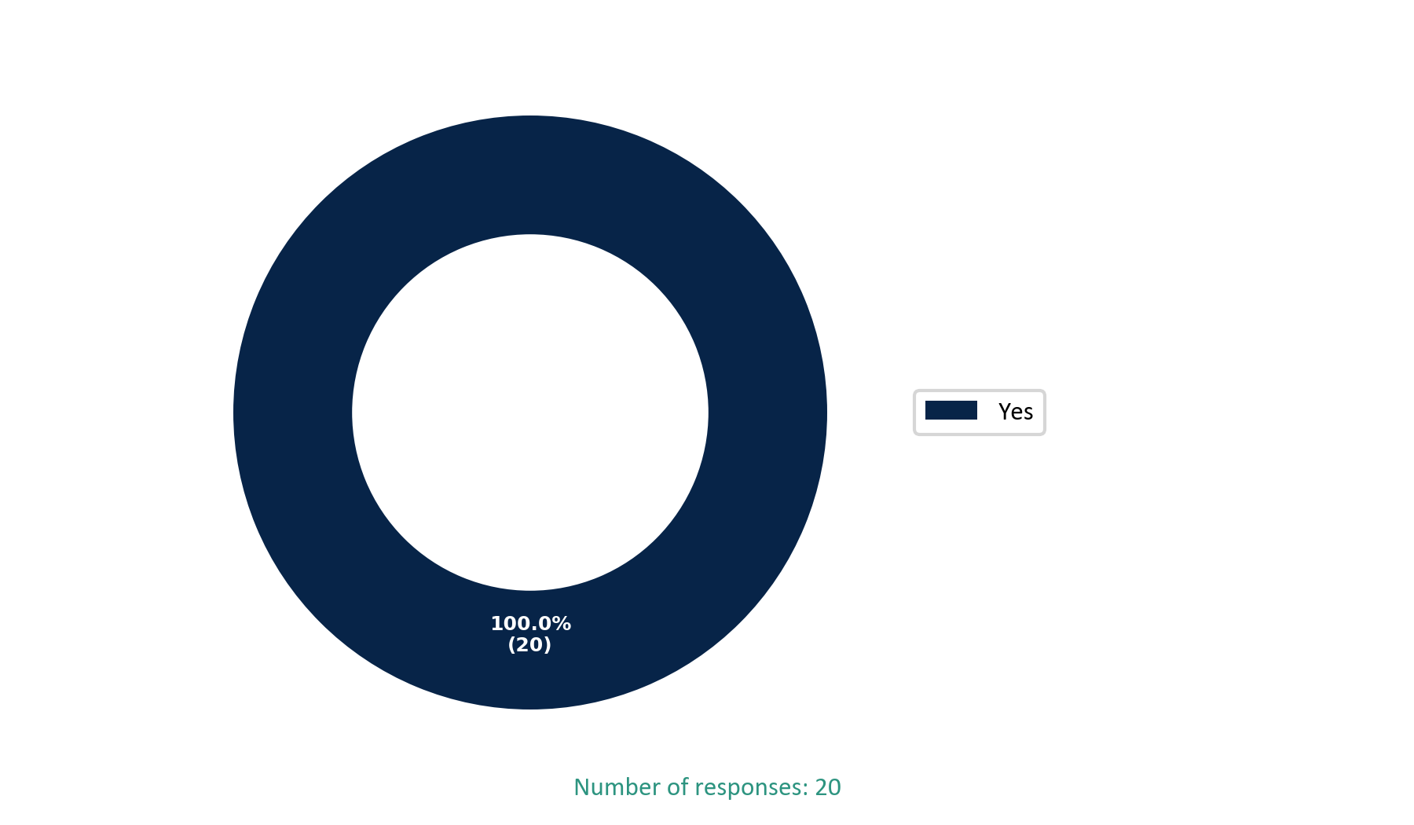

**Q2. Time Spent with Company**

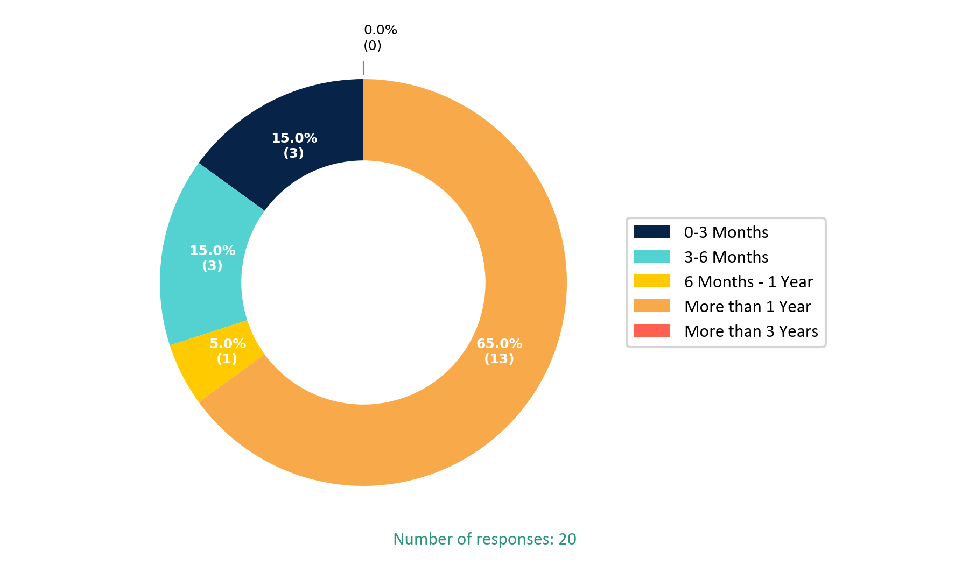

**Q3. Are you satisfied with your Salary?**

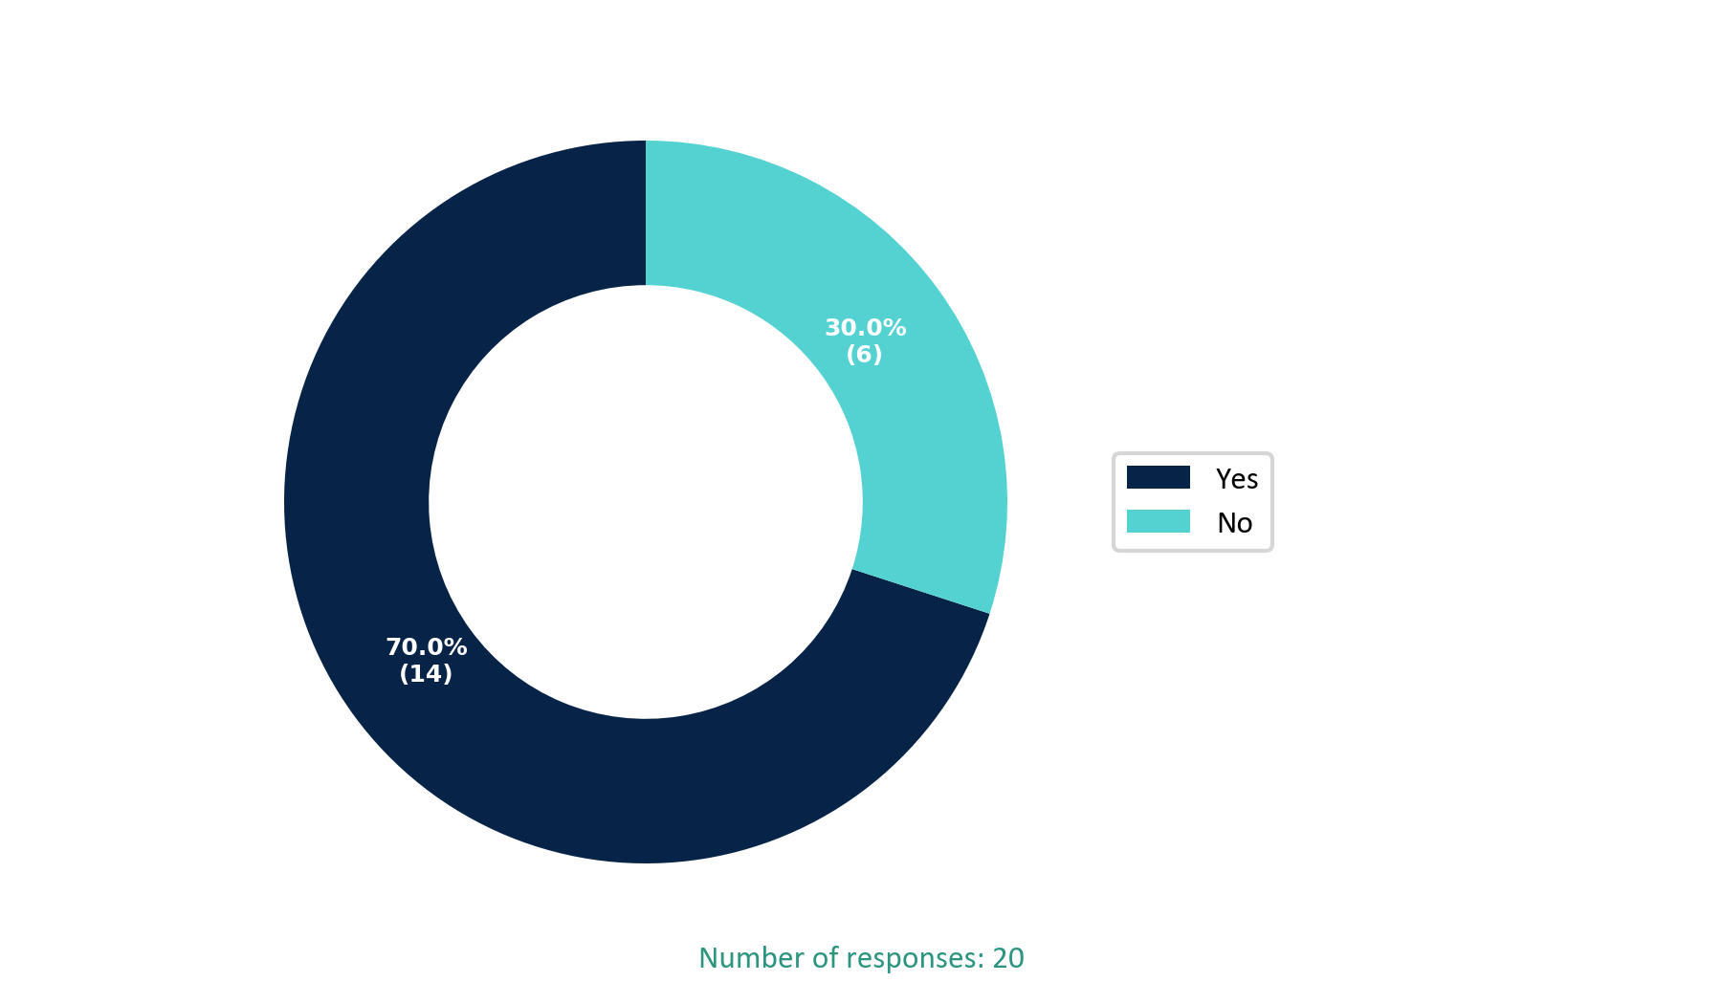

**Q4. Has there been any deduction in your salary? Are the deductions fair or unfair?**

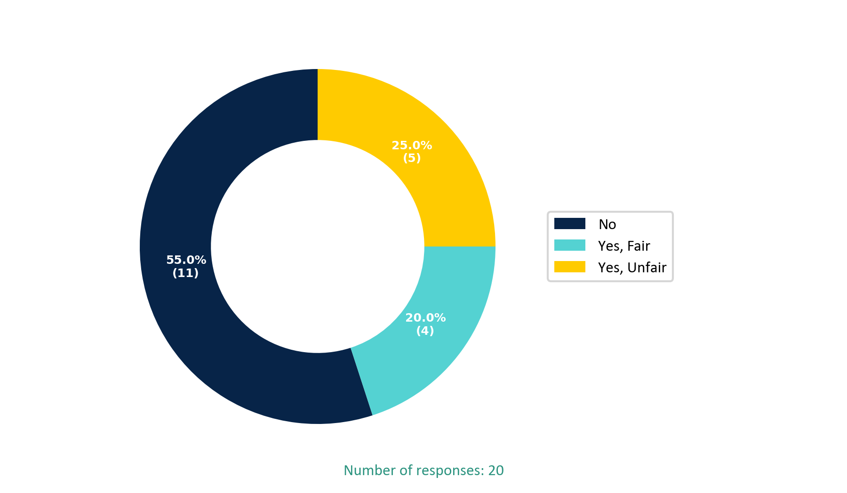

**Q5. How easy/user friendly is it to use the FlowHCM portal and what are the challenges while using the self service portal?**

**Responses:**

**Response 1:** It's very Easy

**Response 2:** Yes we face issues with using FlowHCM because if we want to check our current month pay slip we can't check because they hide it when salary is released. When the 2nd month payroll closed then the payslip of last previous month appears we can't find why our salary is deducted when we ask about decutions in real time just because of this hiding of payslip issue we can't raise or find the resolution of our concern HR should have professional they should know we all have same salary they are not releasing the same salary to all our colleague some is receiving 63k and some are receiving 61k why? There is no answer of this question.

**Response 3:** It's easy to use

**Response 4:** It's easy to use and I have no issue

**Response 5:** Sometimes the portal doesn't work properly

**Response 6:** Minimize the downtime and very slow performance

**Response 7:** Our leaves, cpl and salary not show accurately

**Response 8:** It's not working smoothly

**Response 9:** It's an easy and user friendly portal. Its updates time to time.

**Response 10:** Satisfied

**Response 11:** Poor and pathetic

**Response 12:** It's easy to use but most of the time it's not in working due to technical issues

**Response 13:** All good

**Response 14:** No thanks

**Response 15:** It helps me to track my attendance leave quota etc

**Response 16:** No comment

**Response 17:** Nothing

**Response 18:** This is smooth working

**Response 19:** Not yet

**Response 20:** Expected salary slips do not work. Attendance upload issues with HR which is why the deduction in salary and leaves are the issue

**Q6. Do you know about the following HR policies.**

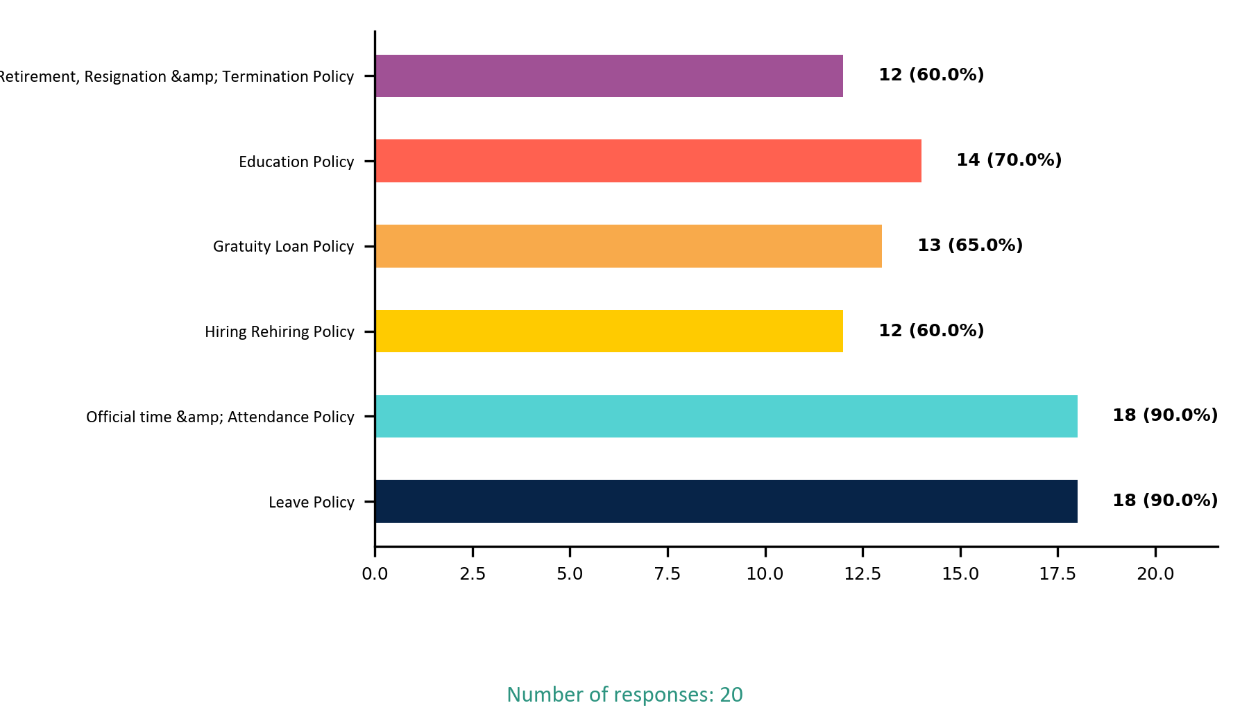

**Q7. Would you like us to provide more context or examples related to the questions listed above?**

**Responses:**

**Response 1:** Yes I Know about all policies

**Response 2:** No thanks

**Response 3:** No

**Response 4:** Na

**Response 5:** No

**Response 6:** No

**Response 7:** Nothing

**Response 8:** No, everything is good

**Response 9:** No

**Response 10:** Leave policy means that you have to tell almost may be 24 hours before shift

**Response 11:** No thanks

**Response 12:** No

**Response 13:** No

**Response 14:** Nothing

**Response 15:** No

**Response 16:** Not right now

**Response 17:** Like other companies we can get our PF amount withdrawn during the services as a loan. Here we can get the loan from our gratuity amount or not? There are no promotion chances even after outstanding consistent performance

**Q8. Does your manager listen and respond when you raise an issue?**

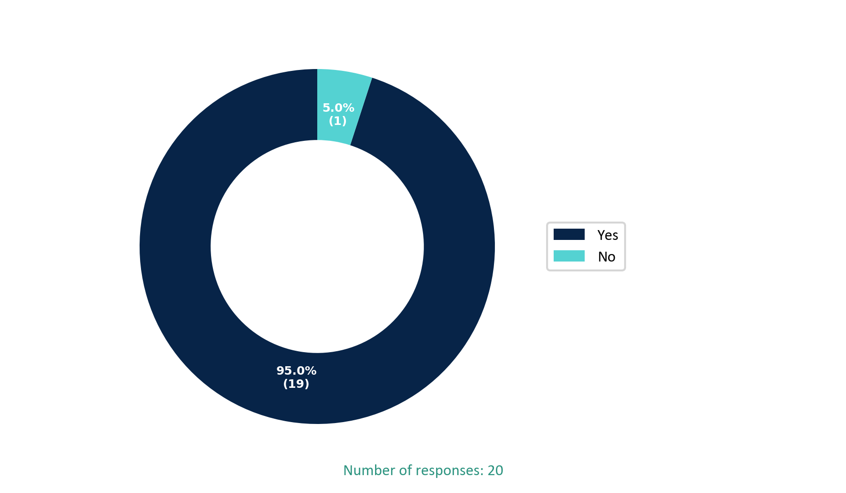

**Q9. Does your management provide feedback regarding your performance?**

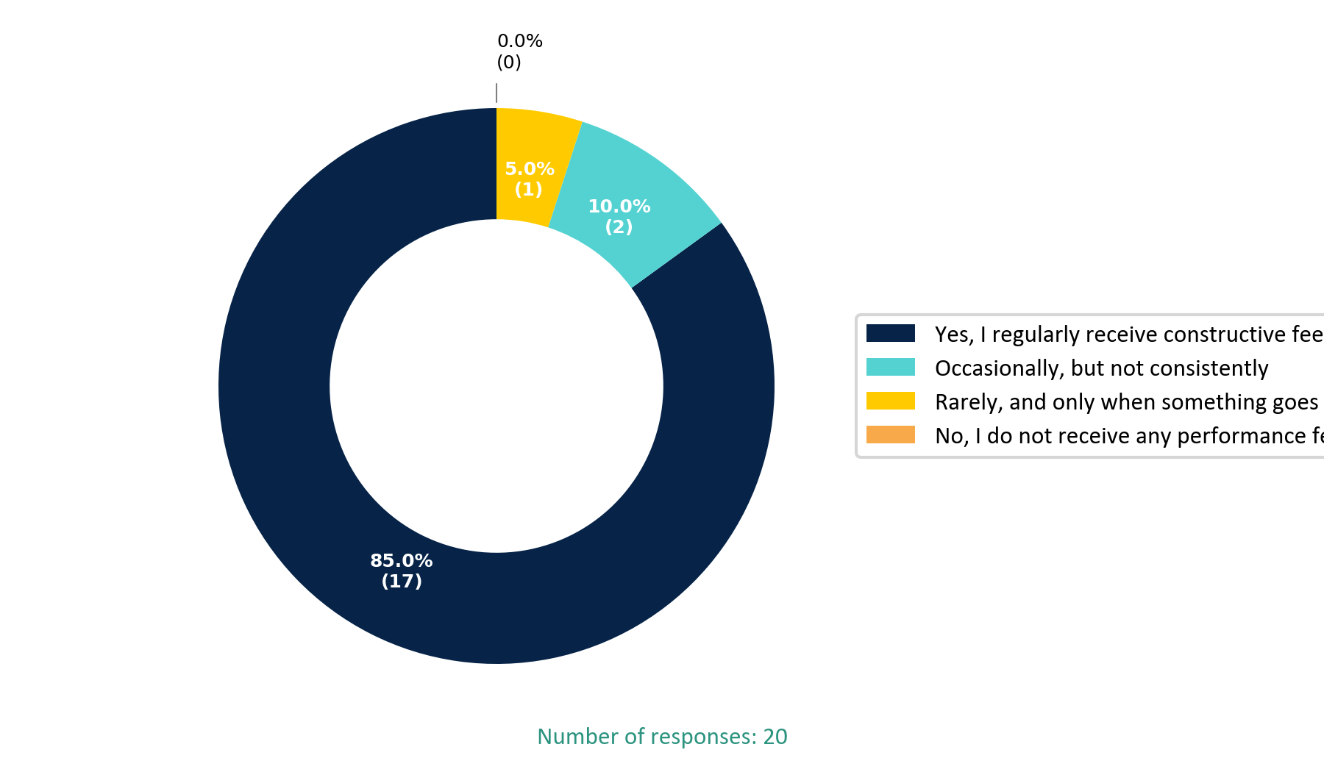

**Q10. Do you feel there are enough opportunities for learning and growth in your current role?**

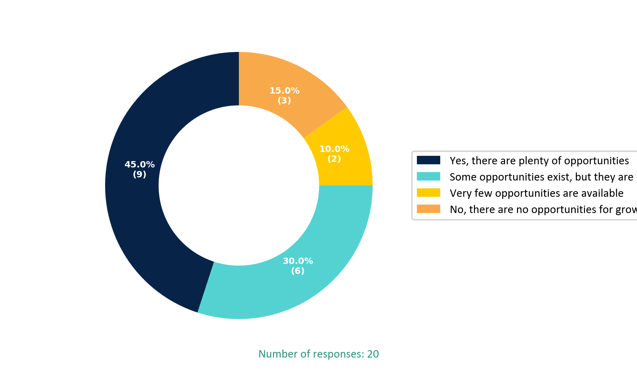

**Q11. Would you like us to provide more context or examples related to the questions listed above?**

**Responses:**

**Response 1:** I am working as Team coordinator and Next Position is Shift Manager position which is not available at the moment

**Response 2:** We need to establish a clear process for long-serving employees who have reached a point in their current role where no further upward positions are available. Rather than letting their roles become stagnant, we should create opportunities for them by offering transitions into other departments,such as restaurant operations or other relevant areas,where they can take on better or more motivating roles. This will help retain talent and keep employees engaged and motivated.

**Response 3:** There have a lot of opportunities but must be provide opportunity to the toppers to be promoted

**Response 4:** Na

**Response 5:** No

**Response 6:** No

**Response 7:** No everything is fine

**Response 8:** No

**Response 9:** Opportunities like you can go in QA team , Gems team etc

**Response 10:** No thanks

**Response 11:** No

**Response 12:** I am clearly informed in front of all supervisors that there are no promotion chances in the next 1 to 2 years at least for me.

**Response 13:** Nothing

**Response 14:** Not right now

**Response 15:** There should be a grading system for top layer specifically. Because there are no growth system in this company so far.

**Q12. Have you ever felt that your manager treats employees differently based on gender?**

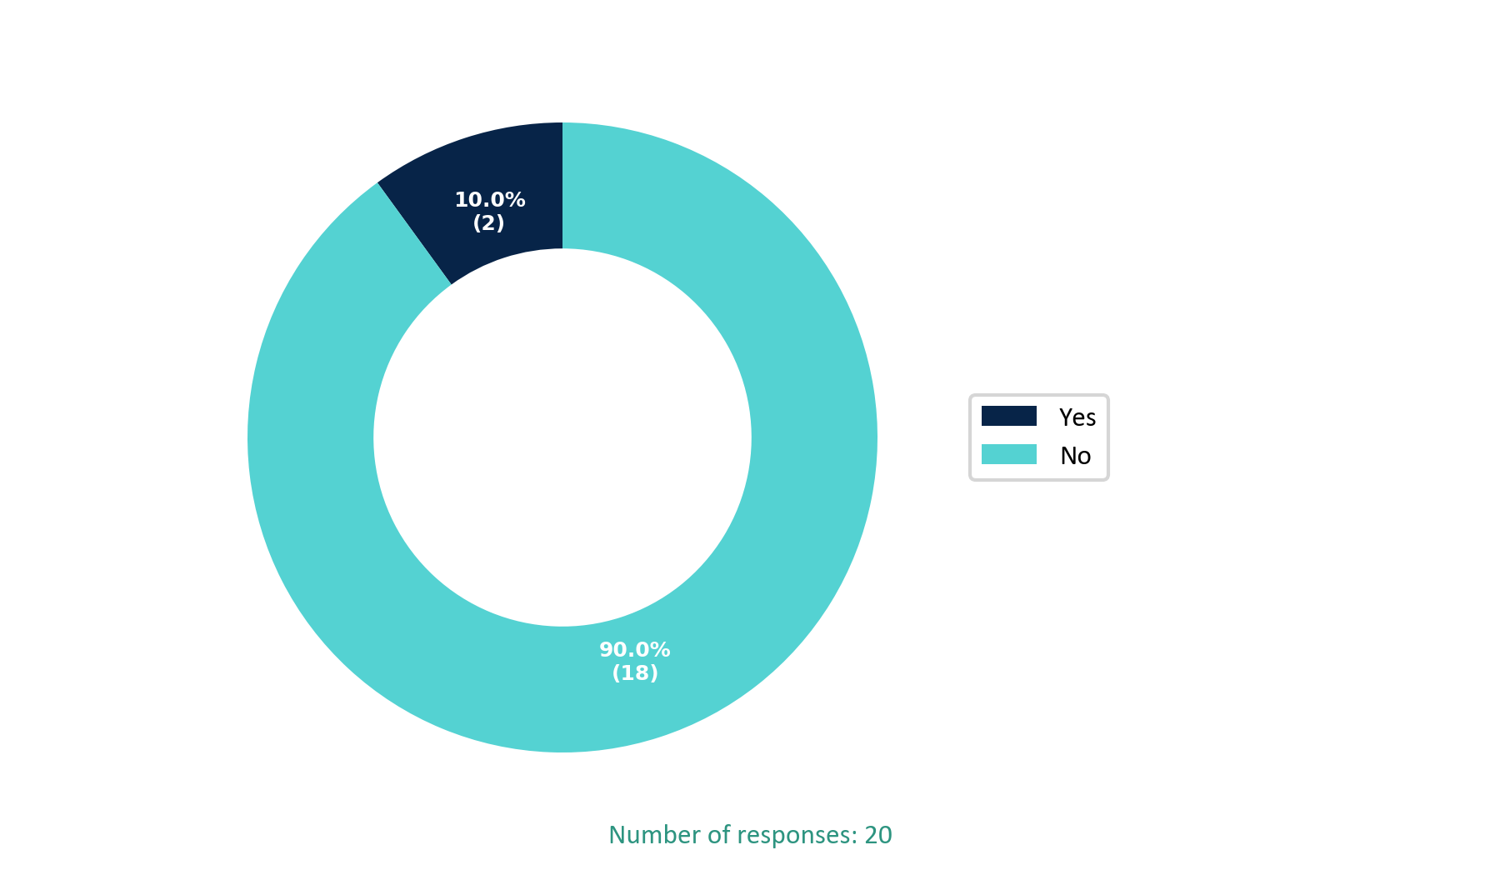

**Q13. Have you ever felt pressured by manager to maintain a personal or intimate relationship?**

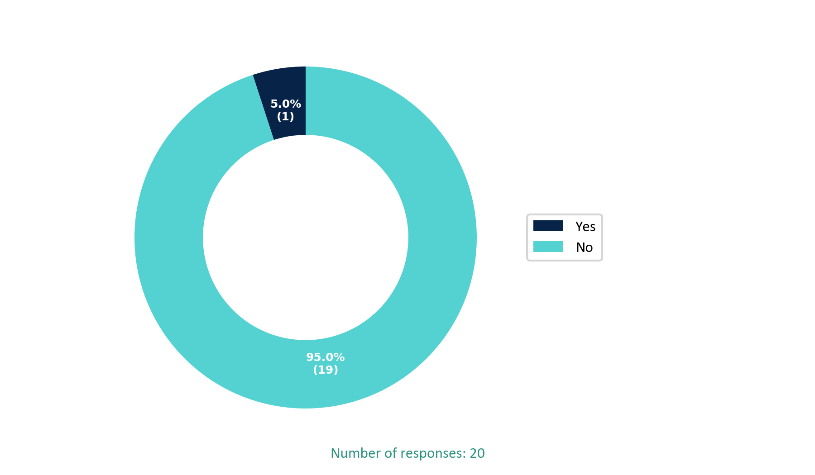

**Q14. Have you experienced or witnessed any form of harassment at the workplace?**

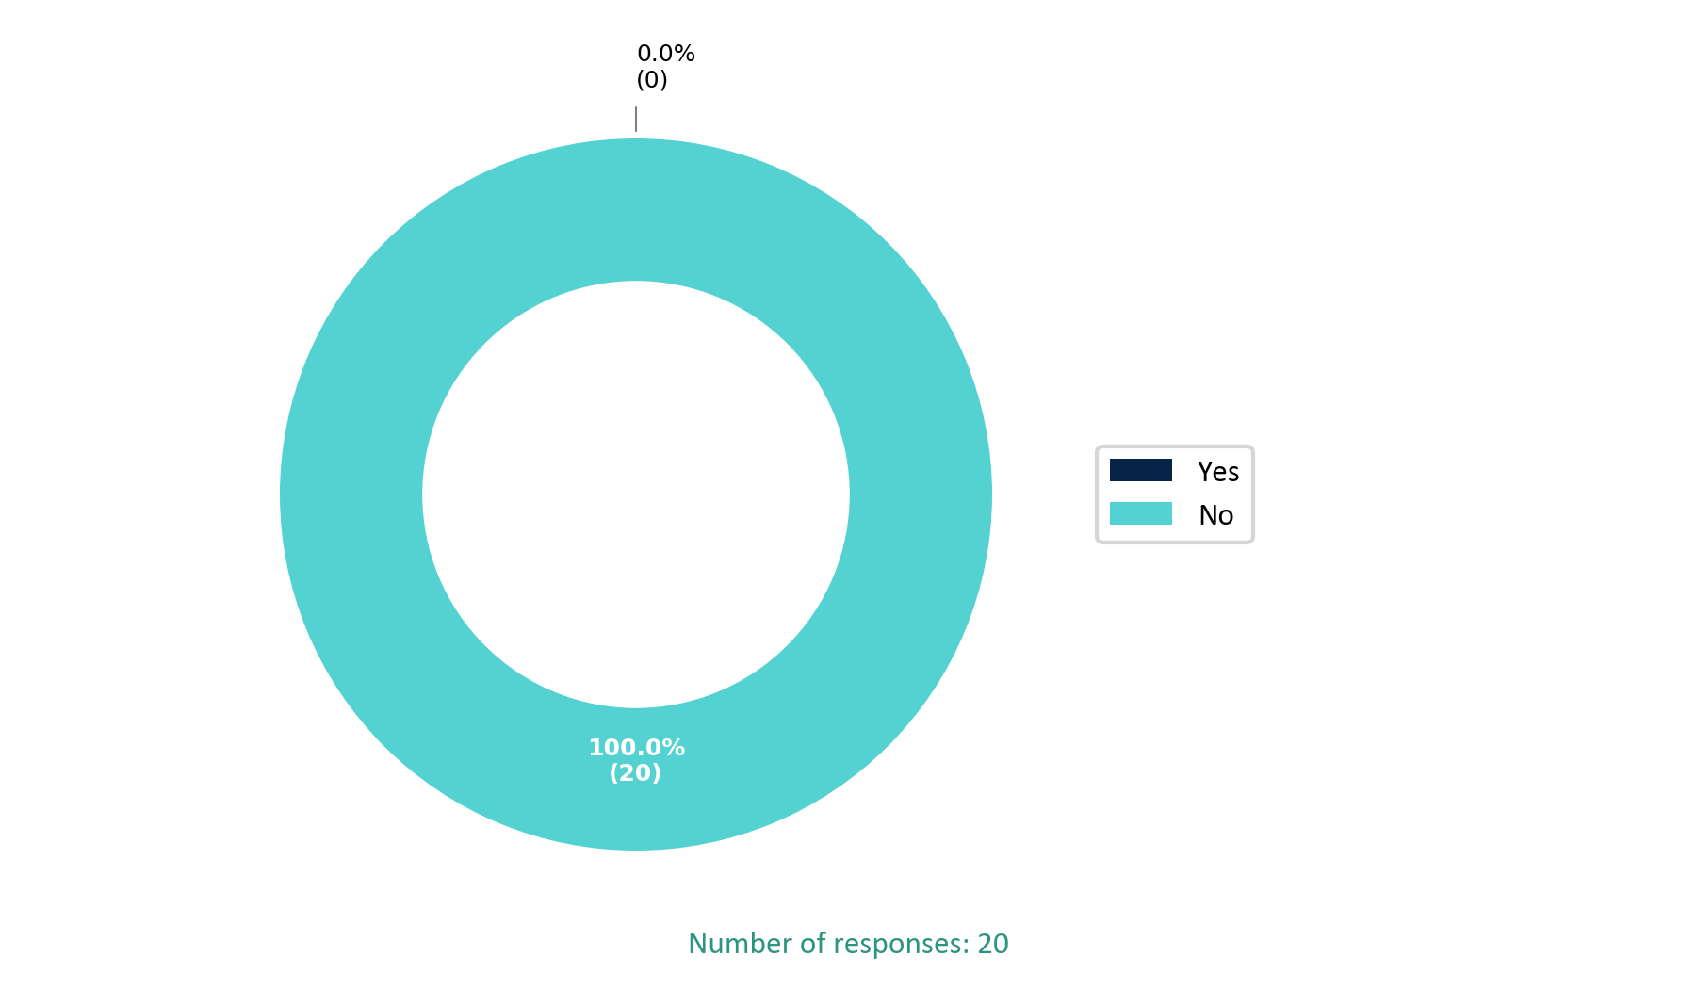

**Q15. Have there been situations or interactions at work that made you feel uncomfortable or unsafe?**



**Q16. Would you like us to provide more context or examples related to the questions listed above?**

**Responses:**

**Response 1:** No thanks

**Response 2:** No

**Response 3:** Na

**Response 4:** No

**Response 5:** No

**Response 6:** No thanks

**Response 7:** No

**Response 8:** No

**Response 9:** No thanks

**Response 10:** No

**Response 11:** Nothing

**Response 12:** No

**Response 13:** Not following the hierarchy from my manager is very uncomfortable thing. It results in disrespectful for my juniors for me

**Q17. 14. Do you know about FOS Grievance Management System active for Cheezious Employees? If yes, why haven't you used FOS yet?**

**Responses:**

**Response 1:** I haven't used yet because I haven't felt need for it

**Response 2:** No

**Response 3:** Currently I am not facing any kind of issue which needs to be escalated.

**Response 4:** Because I feel no need because I'm fully satisfied with my company

**Response 5:** Because I don't feel like using FOS

**Response 6:** Not aware as much before as compared to now

**Response 7:** Yes, but I don't have enough time to use it.

**Response 8:** Yes, I am aware of it

**Response 9:** Because I didn't need it yet.

**Response 10:** No

**Response 11:** I already complain during call on FOS but no feedback received I think it's also useless

**Response 12:** All is going good so I don't feel to use it.

**Response 13:** Not yet need of it

**Response 14:** Yes I'm aware about it currently I do not face any kind of issue which needs to be escalated.

**Response 15:** Yes i know about FOS and so far I didn't need to use it

**Response 16:** Never felt the need for it. Every feedback that I have given below has already been discussed with my reporting manager.

**Response 17:** Yes nothing

**Response 18:** No

**Response 19:** No

**Response 20:** Didn't felt to use it

**Q18. Would you like to share any Complaint, Feedback or Suggestion related to your workplace?**

**Responses:**

**Response 1:** No

**Response 2:** Work stations and chairs should be upgraded  
Transportation for females  
HR should concentrate on their salary related task because there is no rule of them we always receive our salary 1 day late 2 days late should upgrade this system.

**Response 3:**  I would like to recommend that Cheezious higher management consider visiting the call center once or twice a month. These visits would allow leadership to engage directly with frontline team members, listen to their concerns, and provide immediate guidance or support where needed. Additionally, conducting one-on-one sessions during these visits would help strengthen communication, boost morale, and identify improvement areas firsthand.  
  
To further encourage performance, I propose we start recognizing and rewarding team members who demonstrate consistent dedication and outstanding performance.  
  
In addition, I strongly suggest that the company arrange dedicated transportation for our female team members. This initiative would not only enhance their safety and comfort but also reflect our organization's commitment to creating a supportive and inclusive work environment

**Response 4:** Everything is good but need to improve computer which we used ,chairs and our company try to gave us pick and drop further gave opportunities to the seniors as a promotion.

**Response 5:** No

**Response 6:** Salary raise as per current inflation also leaves should be entertained when required.

**Response 7:** I would like to provide some feedback regarding our workplace environment. Firstly, I believe that providing proper and comfortable chairs for employees would significantly enhance their productivity and well-being. Additionally, there are recurring issues with the HR systems that need to be addressed for a smoother experience. It would also be beneficial to assign skills to employees in a fair and systematic manner, ensuring everyone is positioned according to their strengths. Furthermore, I suggest that the company consider providing reliable transportation options for female employees or offering transport allowances to support their commute. Lastly, extending break times to more than one hour would allow employees to rest adequately, ultimately improving focus and productivity. Thank you for considering these suggestions to enhance our work environment.

**Response 8:** Needs to improve system proficiency, Chairs needs to be changed for work with comfort.   
  
Needs to review the weekly off policy as per labour law.

**Response 9:** The system and chair are too bad which makes us so uncomfortable while working .

**Response 10:** Everything is good

**Response 11:** Already registered my complain but good thing is that same issue has been faced in this month I am also not satisfied fos

**Response 12:** Our computer systems must contains atleast 16 GB RAM so that we can perform work efficiently moreover, there should be annual functions or trips so that the employs got some mental relaxation or entertainment.

**Response 13:** Related to workplace there is a need of better infrastructure means tha chairs, computers are not good

**Response 14:** Feedback:  
  
I would like to suggest the following:  
  
Two Weekly Offs: Employees should be given two days off per week to maintain a healthy work-life balance and to improve overall productivity. Continuous work without proper rest can negatively affect both mental and physical health.  
  
System Performance Issues: Many of the systems we use are slow, and sometimes they hang or get stuck. This affects our efficiency and causes delays in completing tasks. It would be very helpful if the technical issues could be addressed and system performance improved.

**Response 15:** No

**Response 16:** There should be some recognition and reward programs like quarterly top performance awards and annual performance recognition events.   
The Umrah award should also be given to supervisors too whether it's bi-annual or annual where any one supervisor with best performance and stats should be sent for Umrah.   
There should be relaxation of 15 minutes for check-in, not for the complete month but at least 2 exemptions should be given in a month. If you arrive even 1 minute late, you have to sit for 1 complete hour extra to complete your shift.   
For the feedback survey, please add some options like "maybe" or "sometimes" in answers. Not just yes and no. Some questions need explanation and some cannot be answered with Yes or a No. Also add the option of remarks and concern details with every question. Not just selective questions.

**Response 17:** Yes

**Response 18:** These suggestions 2 days off are in a week due to our work on regular use headgear and also our system is slow.

**Response 19:** Not right now

**Response 20:** The HR of our company should be very professional and with high authority. Secondly the medical our company is giving is for no use. Employees suffer a lot due to this useless medical. No growth opportunities and no learning opportunities in the company so far.